A SPIRITUAL RETREAT
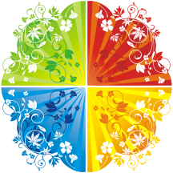
Learning to Be Free

“So if the Son makes you free, you will be free indeed.” John 8.36

When: March 16-18, 2012. Friday 19:00 until Sunday 14:00

Where: to Rome, Italy and then on to Palazzola Center (website: www.palazzola.it ) One can travel to Fiumicino or Ciampino airports.

Cost: travel expenses and 120 euros for room and board.

Jesus repeatedly promises to set His followers free, and New Testament writers liken His passion and resurrection to the Exodus, when God freed the Hebrews from slavery in Egypt. As we approach Easter, then, it is a good time to reflect on what freedom in Christ means. This retreat offers an invitation to explore a range of spiritual practices that can help us begin to experience the freedom that Jesus offers. In particular, we will explore the ways in which Jesus can lead us out of some forms of bondage that we inflict on ourselves. If you have any questions, please do not hesitate to contact Clair+ at: revclair@gmail.com or +43 646720107 for a conversation.

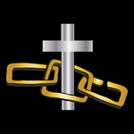

Bill Tompson and the Rev. Clair F. Ullmann will be our leaders this year.

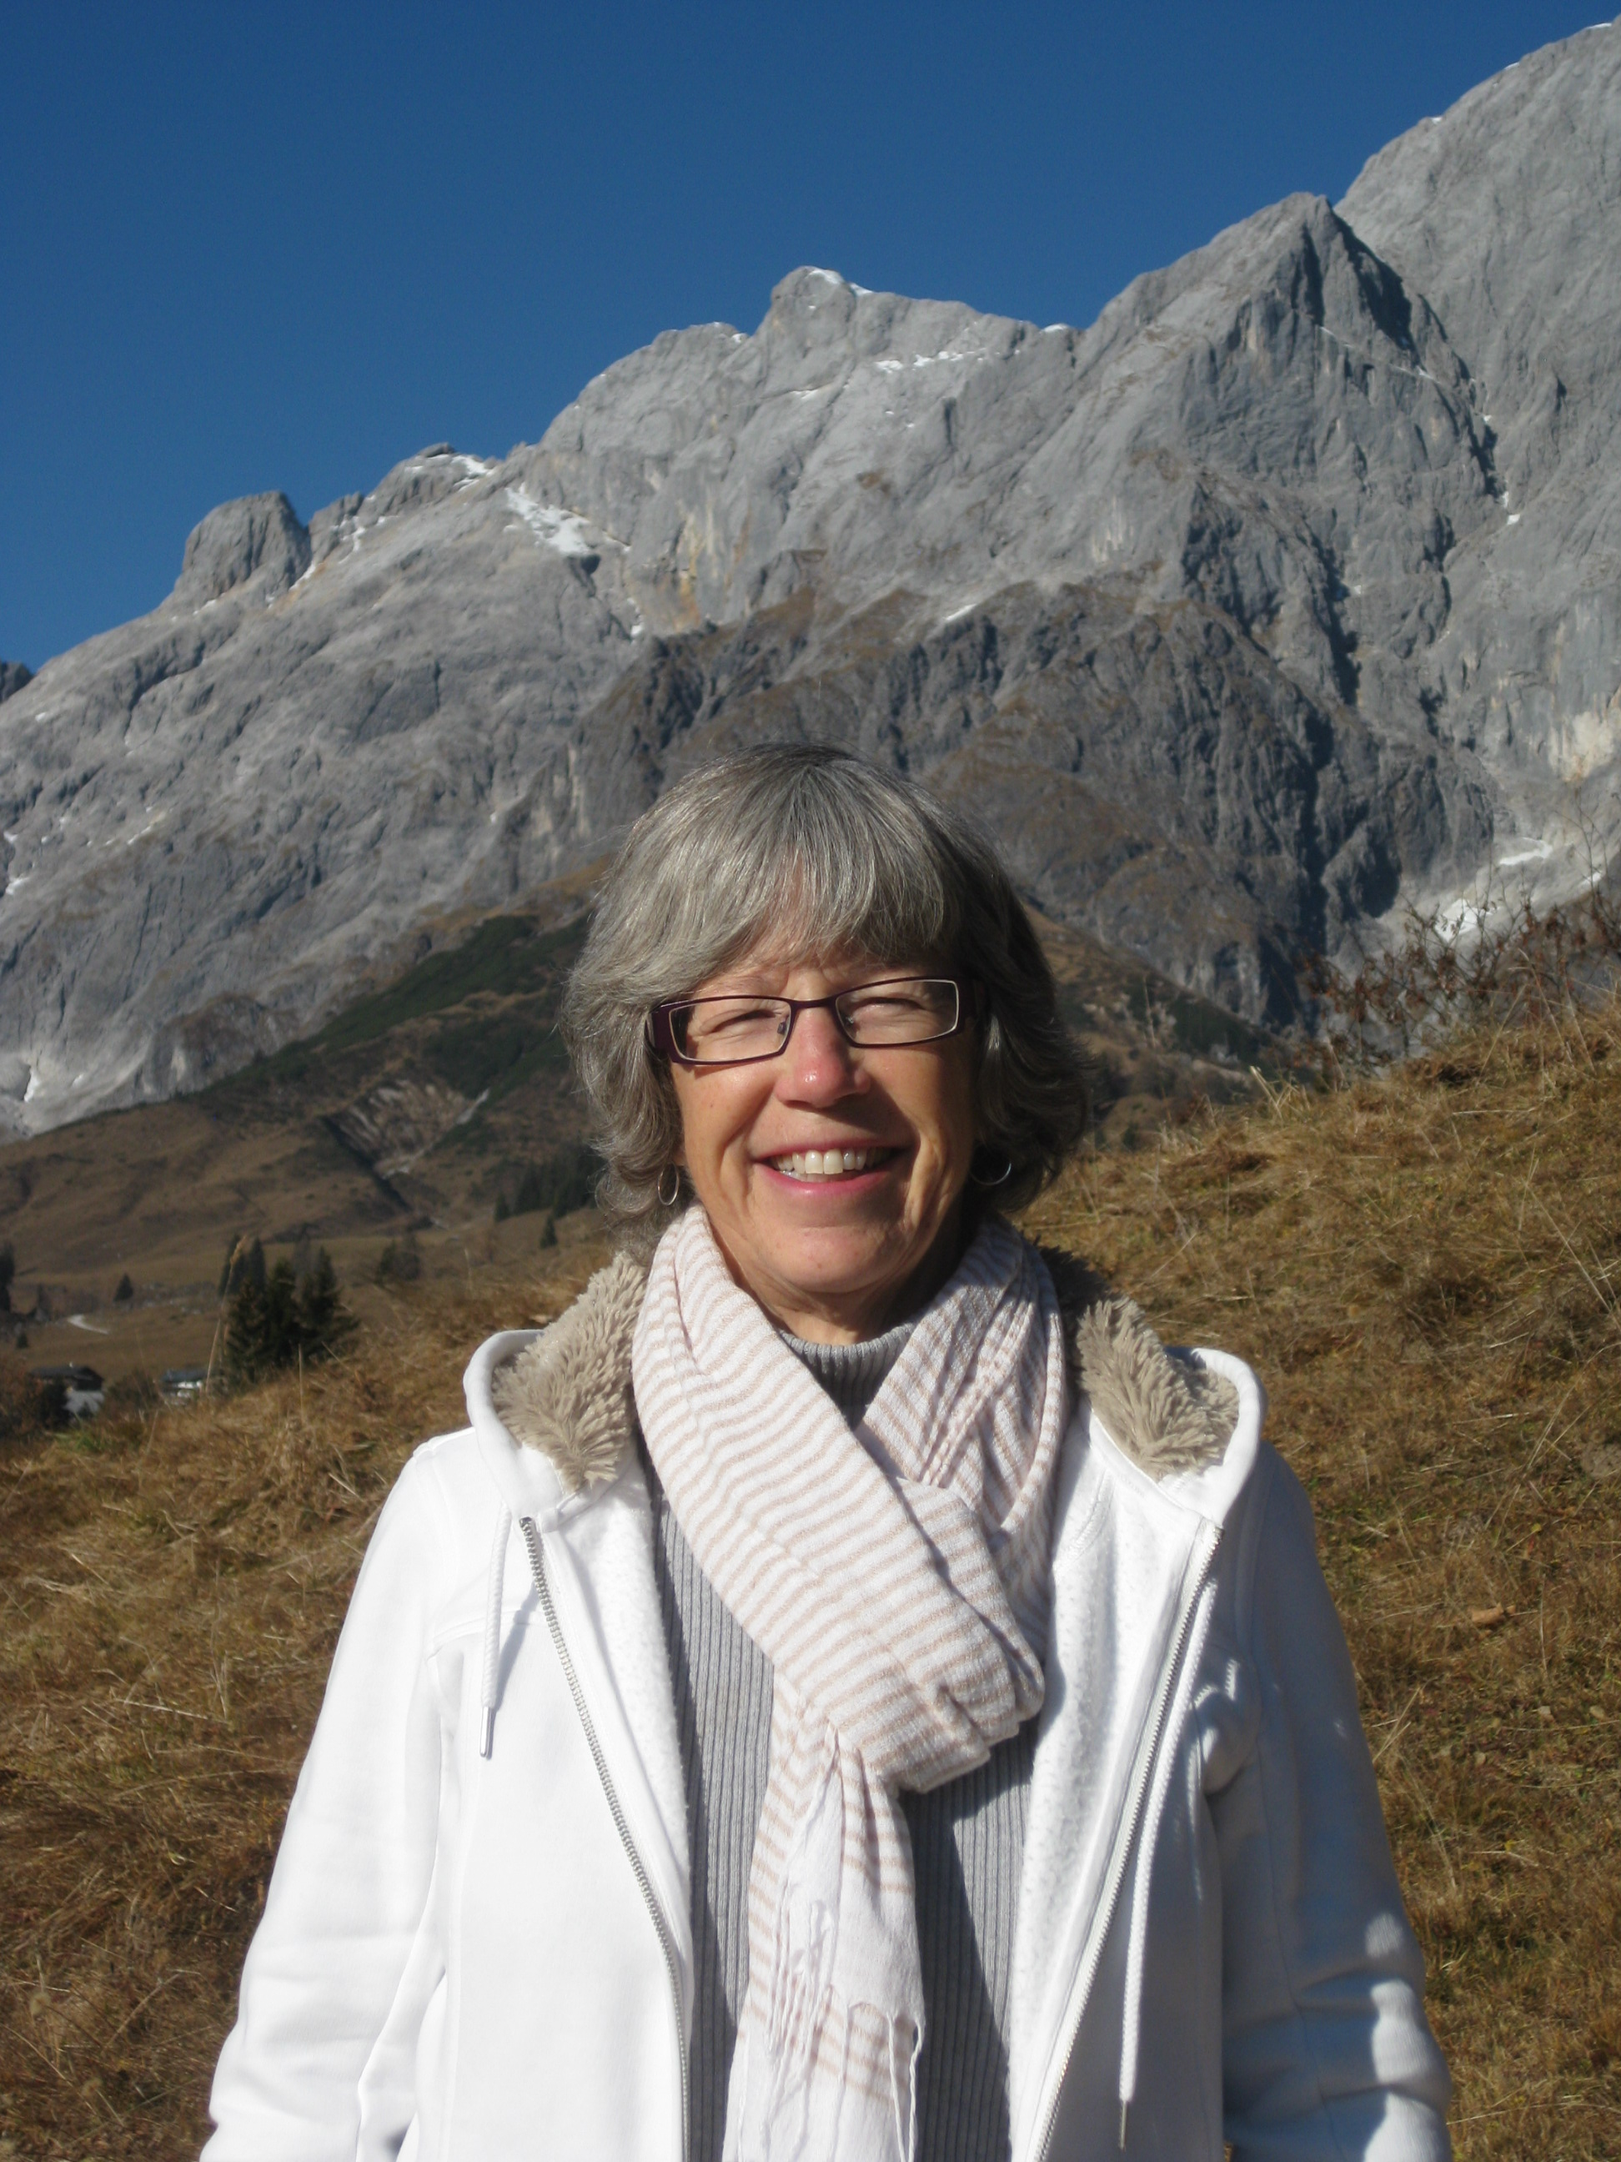
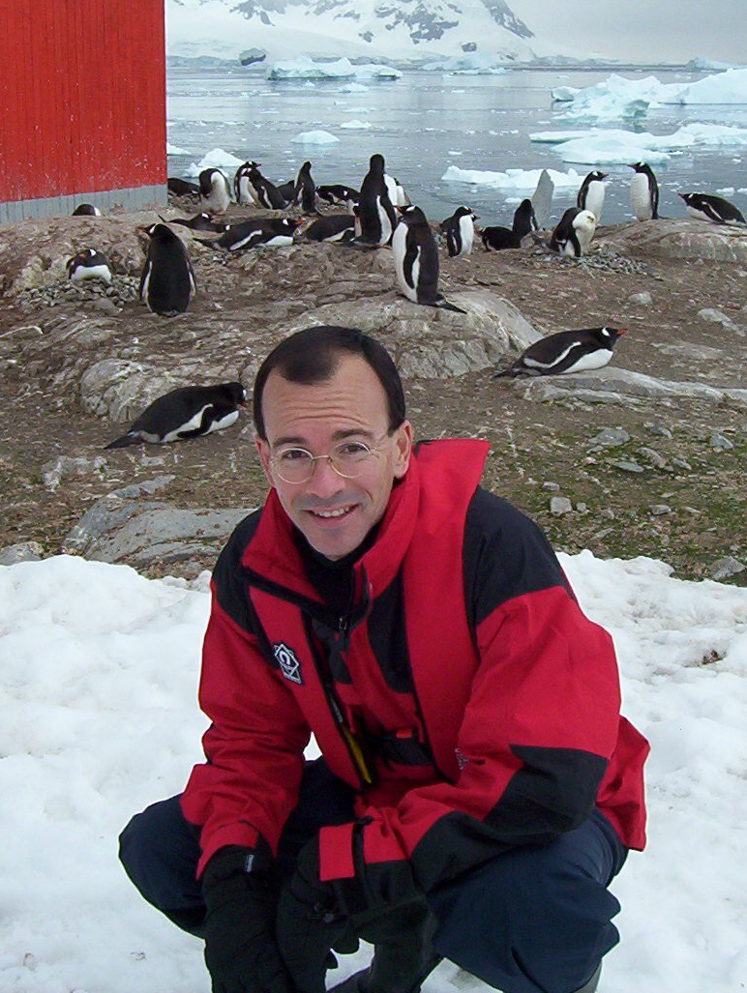
Bill is a senior economist and head of unit at the Organisation for Economic Co-operation and Development, as well as the head of the Adult Education Committee of the Cathedral of the Holy Trinity in Paris. Bill makes no pretense of being an expert on anything to do with Christian spirituality. His theological formation consists mostly of what he has learned from reading, reflection and, not least, his own mistakes over 40 years of trying to follow Jesus.

Clair+ has been a spiritual director since 1989. She studied spiritual direction at the Shalem Institute in Bethesda, Maryland and belongs to Spiritual Directors International as well as Spiritual Directors Europe. She is an experienced retreat leader. Clair serves as a visiting priest at Church of the Ascension, Munich, Germany, and as Vicar of the Chapel of the Holy Family and Kairos Platzl in Mühlbach am Hochkönig, Austria.

“…and you will know the truth, and the truth will make you free.” John 8.32
Sponsored: by the Rt. Rev. Pierre Whalon with The Commission on the Ministry of the Baptized (COMB)
Contact for registration forms and details: The Rev. Clair and Rainer Ullmann,
Email: revclair@gmail.com Tel: 0043 6467 20 107

