A SPIRITUAL RETREAT
Water and the Spirit
“As the deer longs for the water-brooks, so longs my soul for you, O God. My soul is athirst for God, athirst for the living God; when shall I come to appear before the presence of God?”
Psalm 42:1-2
When: March 25-27, 2011. Friday 19:00 until Sunday 14:00
Where: to Rome, Italy and then on to Palazzola Center (website: www.palazzola.it ) One can travel to Fiumicino or Ciampino airports.
Cost: travel expenses and 120 euros for room and board.
How thirsty is your soul? Where is your living God? If these questions resonate with you, come and drink; come and be. This retreat offers a peaceful space to rest in God’s presence, and an invitation to journey with others on this sacred path. Our lives are so busy and God too often becomes a cry in crisis. The theme will be “Water”. It is a mammoth topic and creativity is invited. We know how precious and life giving water is. We are also very much aware of the powerful and destructive force water can be. Come and present yourself to God in loving expectation and longing. God is waiting for you with open arms. If you have any questions, please do not hesitate to contact Clair+ at: crullmann2001@yahoo.com or +43 646720107 for a conversation.
The Rev. Clair F. Ullmann will be our leader this year. Many of you know Clair+ through her activities in the Convocation. Clair+ has been a spiritual director since 1989. She studied spiritual direction at the Shalem Institute in Bethesda, Maryland and belongs to Spiritual Directors International as well as Spiritual Directors Europe. She is an experienced retreat leader. Clair serves as an assisting priest at Church of the Ascension, Munich, Germany and as Vicar of the Chapel of the Holy Family in Mühlbach am Hochkönig, Austria.
Your sister in Christ,
Clair+
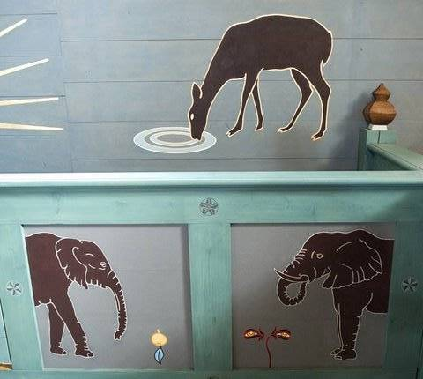

“Take delight in the Lord and he shall give you your heart’s desire”
Psalm 37.4
Sponsored: by the Rt. Rev. Pierre Whalon with The Commission for the Ministry of the Baptized (COMB)
Contact for registration forms and details: The Rev. Clair and Rainer Ullmann,

Email: crullmann2001@yahoo.com Tel: 0043 6467 20 107

